**COMSATS UNIVERSITY ISLAMABAD ATTOCK CAMPUS**

**LAB ASSIGNMENT#02**

**SUBMITTED TO:MR IRSHADULLAH**

**SUBMITTED BY:M MOIZ**

**REGISTERATION NO:FA21-BSE-060**

**SUBJECT:OS**

**DATE:29th March 2024**

**LAB TASKS 3,5**

**GRADED LAB TASK 3:**

You are familiar with adduser command using: man adduser/useradd, man groupadd useradd - create a new user or update default new user information. Create 3 user accounts (user1, user2, user3) and add 2 groups (gr1, gr2). add user1 to gr1 and add user2, user2 to gr2. Check user ID (UID) and group ID (GID) by listing file /etc/passwd. Find lines with added user. What is the UID and GID for these accounts? Write command which show UID and GID for your user name: create 3 files with touch command: files1, files2, files3. Write the command line by using letters with chmod to set the following permissions: rwxrwxr-x for file1 r-x—x—x for file2 ——xrwx for file3 Write the command line by using numbers with chmod to set the following permissions: rwxrwxrwx for file4 (you have to prepare this file) -w for file5 (you have to prepare this file) rwx--x—x for folder1 (you have to prepare this folder) Create two user accounts: tst1 and tst2 Logging in id: tst1, group users, with bash shell, home directory /home/tst1 Logging in id: tst2, group public, with bash shell, home directory home/tst2 For the two accounts set a password. Logging in as tst1 and copy /bin/ls into tst1 home directory as myls file. Change the owner of myls to tst1 and the permissions to 0710. What does this permission value mean? Logging in as tst2 and try to use /home/tst1/myls to list your current directory. Does it work ? Create a new group labo with tst1 and tst2. Change the owner group of myls file to labo. Try again from tst2 account to execute /home/tst1/myls to list your current directory. Does it work?

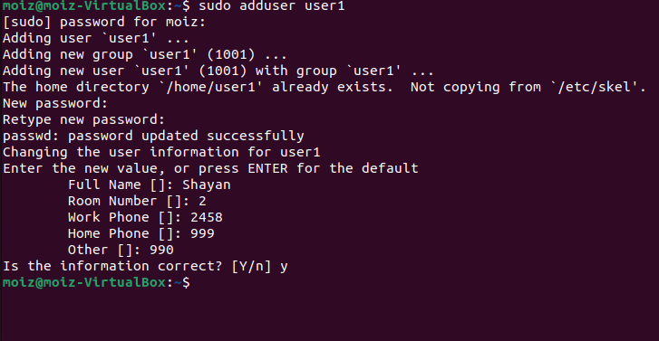

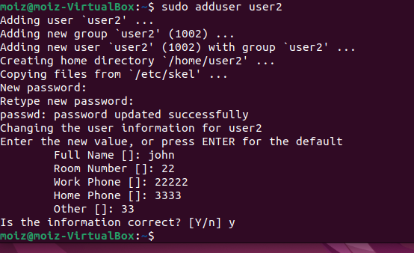

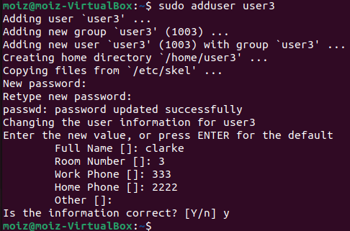





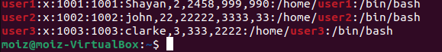

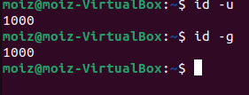

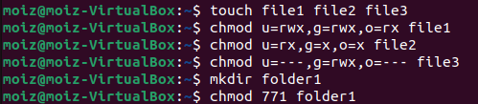

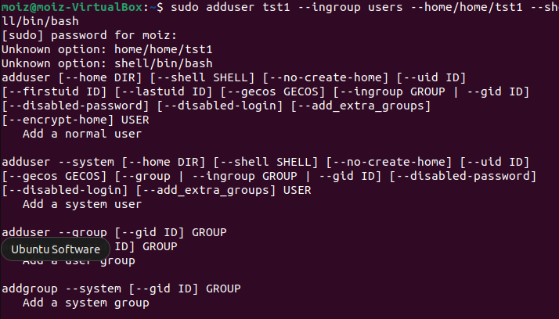

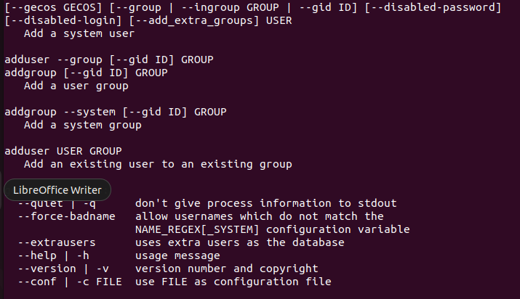

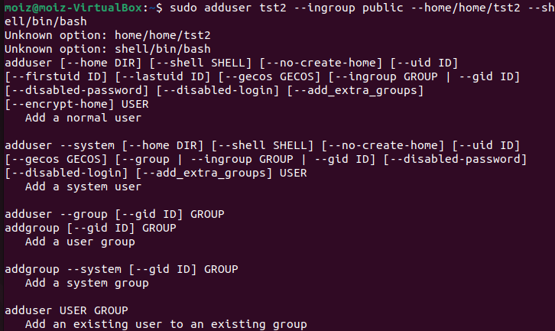

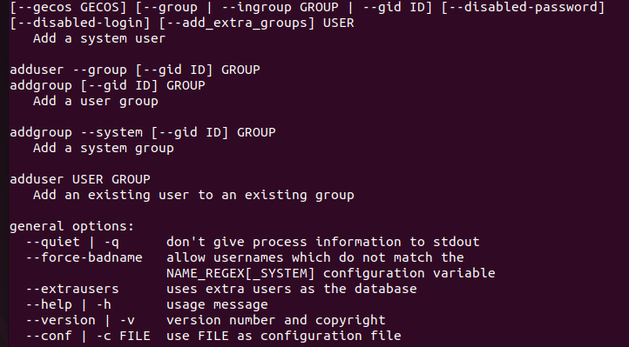

**GRADED LAB TASK 5  
TASK 1.**

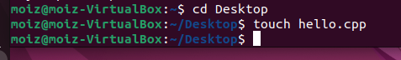

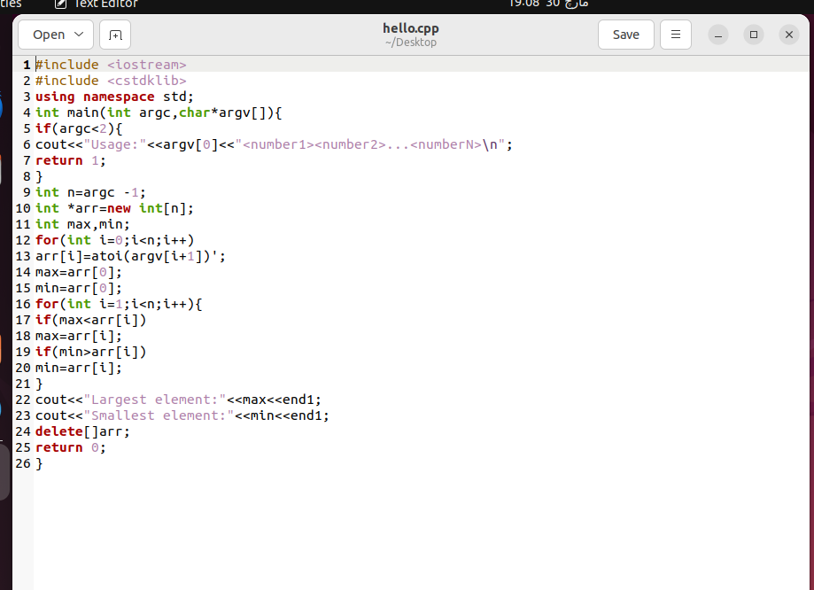

**TASK 2:**